

Lappeenranta University of Technology
Department of Information Technology
Lappeenranta, Finland

Symbian Operating System programming and APIs

IT Project final report

Author: Alexander Kanavin
Supervisors: Antti Sorvari (Nokia), Jan Voracek

Lappeenranta, April 2004

Introduction[2]

Symbian OS is the open, standard operating system licensed by the world’s leading mobile phone manufacturers. It is designed for the specific requirements of data-enabled 2G, 2.5G and 3G mobile phones. Symbian OS includes a robust multi-tasking kernel, integrated telephony support, communications protocols, data management, advanced graphics support, a low-level graphical user interface framework and a variety of application engines.
Key APIs of Symbian 7.0 are shown on the picture:
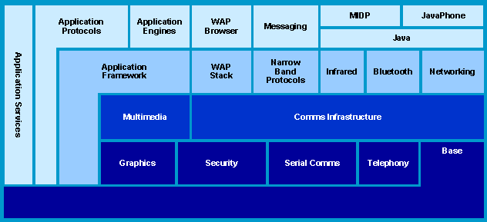

Problem

As a summer trainee at Nokia Research Center I studied Symbian OS application programming interfaces. I have modified already existing applications and wrote some of my own.

The goal

To become familiar with Symbian OS application programming interfaces. Standard tools are going to be used: Nokia’s SDK for Symbian OS ([1]), Microsoft Visual C++, and a Symbian OS mobile phone: Nokia 7650, 3650 or 6600.

Tasks

- Familiarize with the topic
- Study how the existing applications are designed

Results

- The software packages
- The research documentation

Timetable

Literature and resources study – June-July 2003

Actual productive work – from July 2003 to the end of September 2003

Initial presentation - November 2003

Final presentation – April 2004

Links:
1. http://www.forum.nokia.com
2. http://www.symbian.com
3. Richard Harrison, Symbian OS C++ for Mobile Phones, ISBN 0-470-85611-4
4. Leigh Edwards, Richard Barker, “Developing Series 60 Applications”, ISBN 0-321-22722-0

