010595002 - ARTIFICIAL INTELLIGENCE – HOMEWORK 4

Alexander Kanavin - 0242537

In this homewrok I worked with two different expert systems – one is Animal Expert system and theother one is Investor prifler applet.

Animal Expert is an expert system based on propositions, that is a set of if-then rules, that act as a knowledge base. The system allows you to enter your own rules. A typical rule looks like this:

if animal is cat
and animal has tawny color
and animal has black stripes
thenhyp animal is tiger

The rules consist of condition and action sections. When you run the system, it asks you questions from the condition section and uses forward-chaining to add new facts to the database, until it reaches a hypothesis. Then the execution stopps.

A typical session looks like this:

ANIMAL HAS FEATHERS? Yes
ANIMAL LAYS EGGS? Yes

I infer that: ANIMAL IS BIRD

ANIMAL FLIES? No
ANIMAL SWIMS? Yes
ANIMAL IS BLACK AND WHITE? Yes
I infer that: ANIMAL IS PENGUIN is TRUE

This sort of expert systems is quite simple, yet it’s quite good for tasks like diagnosis and classification. A very similar system is used in Microsoft Windows Help facility to diagnose hardware and software problems. However, it has it’s limitations as there’s absolutely no place for uncertainty. There are various approaches that introduce uncertainty and one of them is fuzzy logic systems.

The Investor profiler applet demonstrates how the fuzzy logic systems work. It asks you 18 questions about your preferences and behaviour as an investor, and then tells you what the risk level you can accept. Unfortunately this applet does not provide access to the essential part of the fuzzy logic system – the fuzzy rules.

However, it’s possible to have a look at the fuzzy sets:

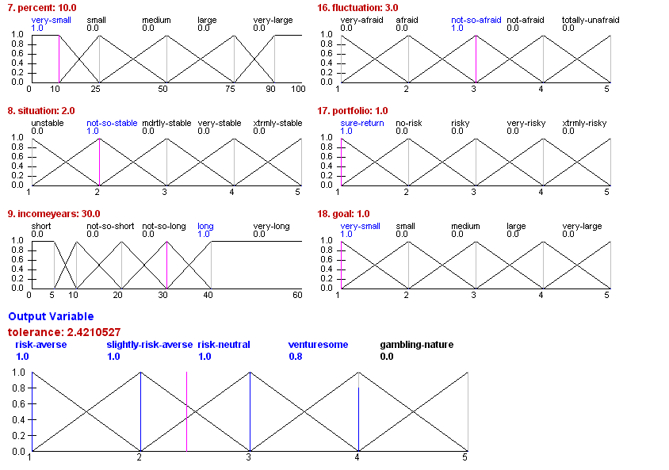

From the picture, we can see that with the answers I gave, I can afford very little risk and should be rather careful with my investments. The applet however does not provide any information on how the fuzzy inference or defuzzyfication is done, and that’s a pity.

Fuzzy logic systems are generally good for things like control, decision making and selection. They are quite close to modelling human-like behavior in these situations.
Fuzzy logic systems are used in industrial systems, intelligent control, decision support systems, and consumer products, such as washing machines and photo cameras.

