010595002 - ARTIFICIAL INTELLIGENCE – HOMEWORK 2

Alexander Kanavin

First, we apply the A* search to the model and get the following result:
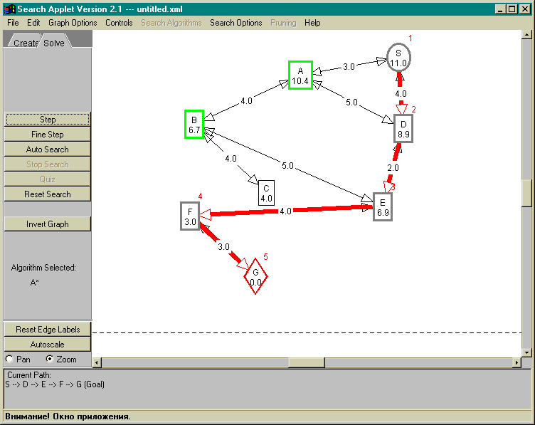
By executing the algorithm step-by-step we see how it works: the f(n) function is calculated for all nodes connected to the current node, and then the node with the lowest f(n) becomes te current one.The final solution is shown on the screenshot and it took the applet five steps to find it.

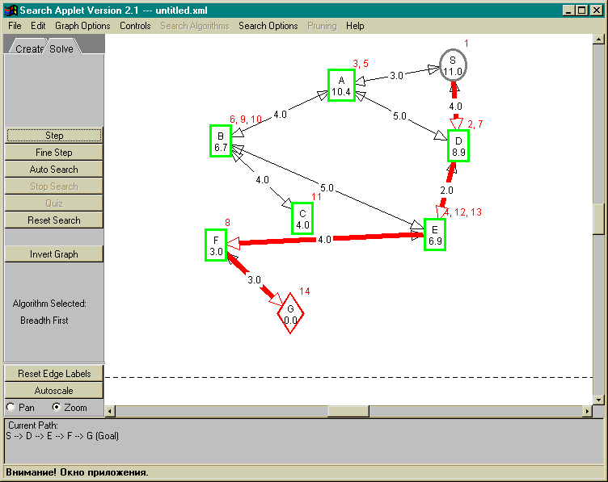
Next we analyze the breadth-first algorithm – the most simple uninformed search algorithm possible. From executing the applet step-by-step it is seen, that the algorithm first tries out all the possible direct routes from S, then all routes from S that go through one (any) town, then all routes that go through two different towns and so on (I switched on the loop detection option). This way, we can see, how the search depth is increased after all possibilities have been explored. This algorithm takes 14 steps to complete, and the second screenshot shows what node was the last one during each step.

The other possible uninformed algorithm would be the depth-first algorithm. However with this configuration it behaves exactly as A* algorithm (it finds the solution in five steps, with no “go-backs”), so it’s quite difficult to comment on how this algorithm makes decisions. I tried modifiing the node heuristics values to trick the algorithm into behaving differently, so that the specifics could be seen, but with no success. It would be useful if the applet provided some feedback on the decisions made by the algorithms during each step.

