LTKK
Lappeenranta University of Technology
Department of Information Technology

User's Guide
Time Accounting Software

Author: Alexander Kanavin
Student number: 0242537
E-mail: kanavin@lut.fi
Supervisors:
Yana Selioukova
Email: Yana.Selioukova@lut.fi
Jan Voracek
E-mail: jan.voracek@lut.fi

Lappeenranta, Finland

2002

1. Introduction 3
2. Functional Description [3] 4
3. References 9

Introduction
The purpose of the time accounting software is to assist in recording the working hours
used for different projects and reporting these hours to different people. The key functionality of the software is storing the time usage data, allowing easy insertion of data, and creation of standard reports [2].
The key functionality for the software is the data insertion, monthly report as an appendix to customer bills, and two graphic presentations of the time used for each project. The first one is a cumulative time during the project lifetime and the other one is a pie chart showing how the time is distributed between different activities. The time accounting software has currently only one interface to other systems, which is an ASCII file for copying the project data to company central project base [2].
The system consists of one page of MS Excel workbook with control elements.
Language of software interface and reports is English. All interface components as dialog windows are standardized to the universal format. The system data will be entered and produced in the Excel format. For changing system data you can apply standard Excel toolbox. The final report is generated and stored in ASCII text format. Graphical reports are presented as MS Graph 2000 components and can be stored to the picture format .
You can use this system to create projects, to add and delete fields of project table, to create and remove entries of table and, of course, to compose monthly, Final and graphical reports based of existing data [3].
For providing this possibilities Time Accounting Software performs next functions:
1. Create new project – a new project is created, you need to specify a project title, initial data of project and deadline.
2. Gather user information – to enter personal information.
3. Add new activity – a new activity is added to Time Accounting table.
4. Delete existing activity – an existing activity with data is removed from Time Accounting table.
5. Add new entry – to add new information about some activity with duration and date.
6. Change time of activity – to change duration of activity.
7. Delete time and delete day from the project – to delete information about some activity
(change duration to zero), if this entry stays empty, then it is removed from table.
8. Produce reports – Produce three type of reports: monthly, Final and graphical reports [3].

Functional Description [3]
2.1 Basic form
The Basic form of the Time Accounting Software is a typical Excel page consisting of the some fields and buttons:
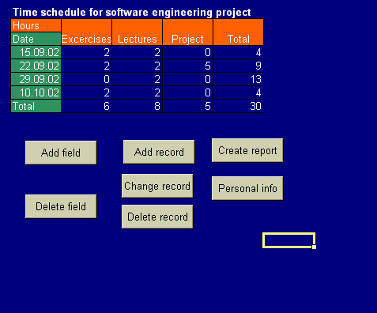
2.2 Create new project
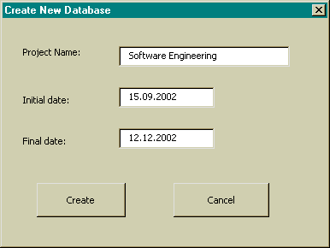
Create New Database dialog is used for creating new database with initial date of project and finale date of project. This dialog is opened when new project is created after pressing button on the Excel toolbox (you can create new project when “Original” sheet of project is active).
You need to enter project name and initial and final date of project.

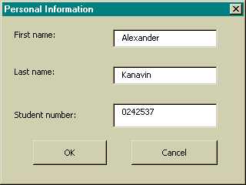
2.3 Gather user information
Enter Personal Information dialog is used for changing the personal information. You can invoke this dialog by pressing the Personal info button:
After that you need to enter your First and Last name and student number.

2.4 Add and remove activity
You can remote or add activity by the New field and the Delete field dialogs that are opened by pressing on Insert field and Delete field button:
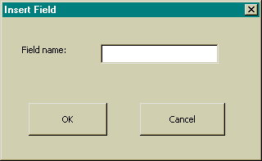
At this dialog you need to enter name of new activity.

2.5 Add new entry
When you press on Insert data button Insert data dialog is opened. It is used for enter new data to database:
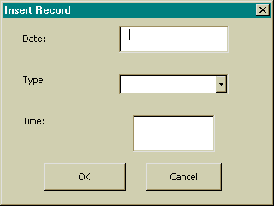
At this dialog you should specify date, type of activities and time that you spend of them.

2.6 Change time of activity
Change data dialog is required for the changing time; this dialog is invoked by pressing Change record button when you select cell in which data should be changed:
You need to enter new time of activity.
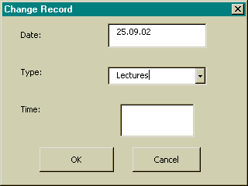
2.7 Delete time and delete day from the project
You can delete time of activity or remove one day from the project. In first case, you should select cell with time and press Delete data button. If you want to delete day from project you should select day and press Delete record button the Delete record dialog will be invoked:
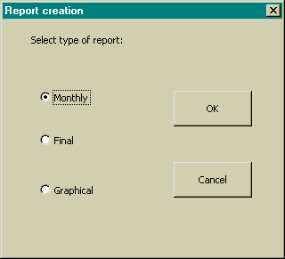
2.8 Produce reports
Create report dialog is used for report creating. You can create monthly, final or graphical reports. You can cause Create report dialog by pressing the Create report button:

When you select the monthly report dialog the Select Month dialog is invoked. At this dialog
you should select a month and enter year for the report:
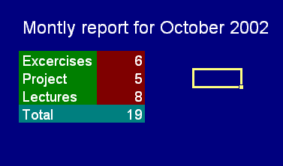For example, you can take this kind of monthly report:

After pressing Create button of the Create report dialog for final report are needed to enter a name of the report file at the Standard Save dialog:
When you select Graphical reports the two graphs will be added to workbook:

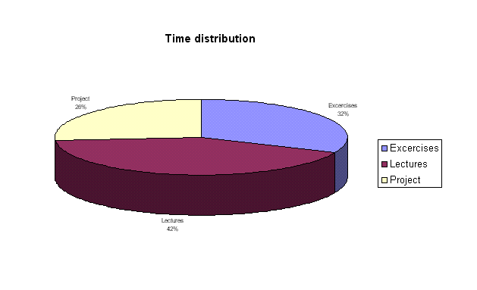
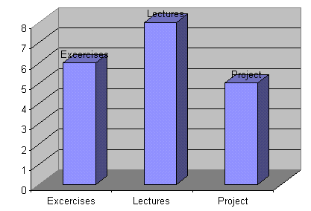

References
1. Pressman, R. S.: Software Engineering, A Practitioner's Approach (European adaptation, fifth edition). McGraw Hill, 2000.
2. Project plan of Software Engineering project
3. Requirements documentation of Software Engineering
4. Implementation plan of Software Engineering project
5. Elisabeth Boonin, Using Excel Visual Basic for Applications, QUE, 1996

