LTKK
Lappeenranta University of Technology
Department of Information Technology

Requirements document
Time Accounting Software

Author: Alexander Kanavin
Student number: 0242537
E-mail: kanavin@lut.fi
Supervisors:
Yana Selioukova
Email: Yana.Selioukova@lut.fi
Jan Voracek
E-mail: jan.voracek@lut.fi

Lappeenranta, Finland

2002

Current State Description
The task is to manage the project that implements the time accounting software, based on MS Excel macros. Because the project is quite small I am the only software engineer assigned to it [2].
The purpose of the time accounting software is to assist in recording the working hours used for different projects and reporting these hours to different people. The key functionality of the software is storing the time usage data, allowing easy insertion of data, and creation of standard reports [2]. This program allows checking the time holding for each activities of software process design (such as exercises, lectures in our cases).
This project consists of customer and supplier representatives.
Jan Voracek plays the role of a customer’s IT manager and represents the customers. I am the supplier’s project manager and software engineer assigned to it. However, I may have access to my company specialists that are willing to discuss the possible problems with me. Despite that I need to implement all the solutions myself. [2]
This project has already started in the middle of September (see the project schedule at [3]) and this document is the report for the second deadline. This document describes requirements for the project. New requirements and changing situation for the project are reflected, too. Goals, tasks and common objectives were described in the Project Plan [3]. Risks and required resources of project were estimated as middle between marginal and negligible.
The percentage complete of the project is approximately 30-40%. The Project Plan [3] was completed and the basic directions of project were defined. Literature for the project was collected.
The environment of development was studied. The user interface and report
prototypes were designed by using Excel forms.
The state of project is normal because the requirement stages of project schedule were completed successfully and established favorable conditions for continuing with the project.

Desired State Description
The presented document is a final part of preliminary specification of the Time Accounting Software Project. Risks, resources, requirements and constraints are already defined and it is now possible to start the implementation phase. The development of the system will be done in MS Excel 2000 and Excel Visual Basic for Application environment. The project is expected to run under Windows 2000 and later versions and will provide the standard-looking dialog windows with Graphical User Interface control elements.
The end-user can use Time Accounting Software system with the standard MS Excel facilites. The system will consists of one page of MS Excel workbook with control elements. Language of software interface and reports is English. All interface components as dialog windows are standardized to the universal format. The system data will be entered and produced in the Excel format. For changing system data user can apply standard Excel toolbox. The final report will be generated and stored in ASCII text format. Graphical reports will be presented as MS Graph 2000 components and can be stored to the picture format.
The user should be able to create projects, to add and delete fields into the project table, to create and remove entries (rows) of the table and to produce compose monthly, final and graphical reports based on existing data.

In order to provide these features, the Time Accounting Software should perform the following functions:
1. Create new project – a new project is created, the user specifies a project title, initial
data of project and the deadline.
2. Gather user information – the user enters his personal information.
3. Add new field – a new field (column) is added to the Time Accounting table.
4. Delete existing field – an existing field with data is removed from the Time Accounting table.
5. Add new entry – the user adds new information about some activity with the duration and date.
6. Change existing entry – the user changes duration of activity.
7. Delete existing entry – the user deletes information about some activity (change
duration to zero), if this entry stays empty, then it is removed from table.
8. Produce reports – Produce three type of reports: monthly, final and graphical reports.
The implemented interface should be ergonomic and friendly; all function should be easy to understand.

Viewpoints
For this document, the viewpoints model propsed in [4] was used. This model does not impose any restrictions on the types of viewpoints, however it suggests the structure of them. Viewpointsmay be used during the early stages of a requirements engineering process as a structuring mechanism for requirements elicitation and analysis.

The viewpoints consist of the viewpoint name, the focus (which is basically a brief description of the viewpoint), the concerns (which tell why this viewpoint is important), the sources (who is the source of the requirements), the viewpoint requirements and the viewpoint change history.
Three Time Accounting Software viewpoints can be identified:
1. The User Interface The user interface provides a communication mechanism between the user and software.
2. Software specification Documentations that are required for design process.
3. System functions Functions are performed by the system.

Viewpoint name | The User Interface
Focus | The interchanging mechanism between the user and system provides input of data by the user, describes forms of report and a view of the dialog windows.
Concerns | Usability, data representation
Source | Customer
Requirements | UI1 (easy insertion of data, and creation of standard reports):  Software should provide an easy way to change data.  UI2 (learning time should be minimal):  The user should only have knowledge of MS Excel 2000 and MS Windows 2000 for understanding how the Time Accounting Software works.  UI3 (management of the system should be easy):  System administrator should not have problems with installation, uninstallation and managing of the Time Accounting Software.  UI4 (software must fit in a 1152 * 864 pixel screen so that the usage is possible without extensive scrolling all the time):  Visible screen should have maximum 1152 * 864 I/O area.
Changes | UI4 requirement was added during time of requirement specification stage

Viewpoint name | Software specification
Focus | A proper set of documentation is required in order to deliver high-quality software in time
Concerns | Maintainability of the product
Source | Customer, supplier
Requirements | SS1 (Project plan required): The Project Plan describes goals, objectives and constraints of project, evaluates resources and determinates risks of project.  SS2 (Requirements Documentation required): The Requirement Documentation is reflected set of project requirements, presented a view of user interfaces and system prototyping. The state of project is evaluated.  SS3 (Implementation Plan required):  SS4 (Project Binder required):
Changes

Viewpoint name | System functions
Focus | What functions the software should perform and what’s the best approach for their implementation
Concerns | Reliabilty and stability of the software, performance and expandability
Source | Supplier and customer
Requirements | SF1 (data insertion and modification function): The software should perform data manipulation operations.  SF2 (create monthly report function): Time Accounting Software should create monthly report as a table.  SF3 (create two graphic presentations function): This software should complete the time distribution report and the cumulative time distribution report as graphic diagrams.  SF4 (create final report): Software should create final report in ASCII format for adding information to the central database.  SF5 (simple realization of functions): The implementation should be as simple as possible.
Changes

Scenarios
This section gives a brief overview of how the user typically interacts with the system. For more detailed specifications and GUI prototypes please refer to Appendixes.

The user starts working with the system by creating the new project databese or opening an existing one. He presses a special button on the Excel toolbox. If the database already exists, the user opens it by the means of the standard Excel Open file… dialog from the File menu). After he will have ‘Welcome’ dialog.
If the user creates a new database, he is presented with the ‘Create new database’ dialog window.. User needs to fill in the project name, initial date of project and the deadline.
When this is completed, the standard table will be created. The user then can add fields and data or modify them by pressing the respective buttons on the main window. The buttons for manipulating data are 'Insert field', 'Delete field', ‘Add record’, ‘Change record’ and ‘Delete record’.
For creating reports user should click ‘Create report’ button which will invoke the ‘Create report’ dialog. In this dialog the user selects the type of report (monthly, final or graphical) and clicks the 'Create' button. If the user selected ‘Graphical’, then two graphic reports will be created in MS Graph2000 format. If the ‘Final’ type of report was selected, the ‘Save’ dialog will apper and user should enter the file name for final
report and press the ‘Save’ button. If ‘Monthly’ type of report was selected user needs to select a month in the dialog that appers and after clicking ‘Select’ button the report will apper in a form of an Excel spreadsheet.

Acknowledgements
Thanks to Jan Voracek for his very interesting lectures on Software Engineering.
Also I would like to thank Yana Selioukova for her help with this project and the links and materials provided on the course webpage.
Special thanks go to Viacheslav Izosimov who answered many questions I had about various sections of this document.

Total Time Used for Different Course Activities so Far
Apart from the lectures and excercies that take 4 hours every week, I have also spent
2 hours preparing for the excercises on 24.09, 5 hours writing the project plan, and a total of 10 hours writing the Requirements document (including all the reading, UI prototypes etc.).

References
1. Pressman, R. S.: Software Engineering, A Practitioner's Approach (European
adaptation, fifth edition). McGraw Hill, 2000.
2. Software Engineering Homepage
http://www.it.lut.fi/kurssit/02-03/010752000/projects.html
[cited 30.10.2002]
3. Project plan of Software Engineering project by Alexander Kanavin.
4. Sommerville, Ian, Pete Sawyer, and Stephen Viller (1998), Viewpoints for
requirements elicitation: a practical approach, in Proceedings of the IEEE
International Conference on Requirements Engineering - ICRE'98, April 6-10,
1998, Colorado Springs, Colorado.
5. Excel Tutorials http://lacher.com/toc.htm[cited 12.03.2002]
6. VBA Tutor Lessons http://www.vbatutor.com/vbatutor.htm[cited 12.03.2002]
7. Volere Requirements Specification Template, Suzanne Robertson and James
Robertson, The Atlantic Systems Guild
8. Structuring Use Cases with Goals, Alistair Cockburn,
http://members.aol.com/acockburn/papers/usecases.htm [cited 12.03.2002]

Appendix 1: User Interface Prototypes
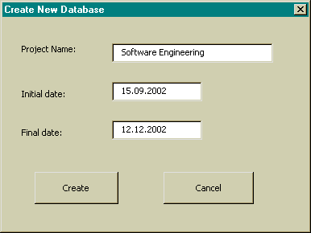
Create New Database dialog is used for creating new database with initial date of
project and finale date of project. This dialog is opened when new project is created
after pressing the button on the Excel toolbox:
Personal Information dialog is used for changing the personal information.
User invokes this dialog when he presses on Personal info button:
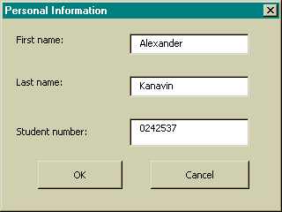
The Basic form of the Time Accounting Software is a typical Excel page consisting of
the some fields and buttons:
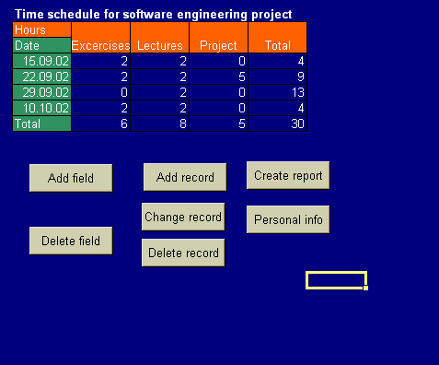
User can add fields with theInsert field dialog that is opened by pressing on Insert field button:

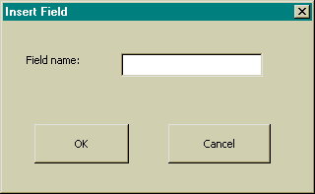

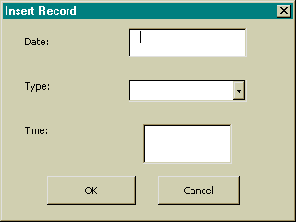
When user presses on Insert data button the Insert record dialog is opened. It is used for adding new data to the database:
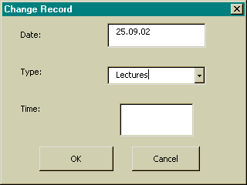
Change record is required for the changing data; this dialog is invoked by
pressing Change record button:

Create report dialog is used for report creating. User can create monthly, final or
graphical reports. User causes Create report dialog by pressing the Create report
button:
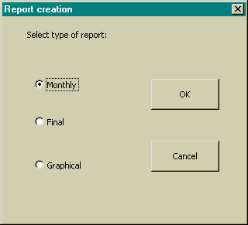
Appendix 2: Report Prototypes
Format of the monthly report:
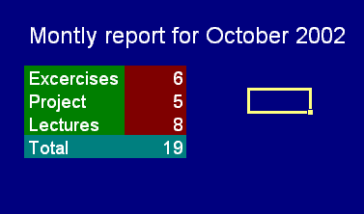
Format of the final report:
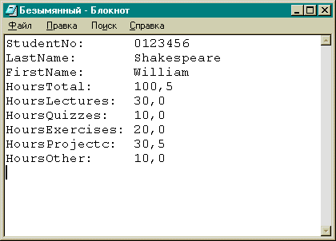
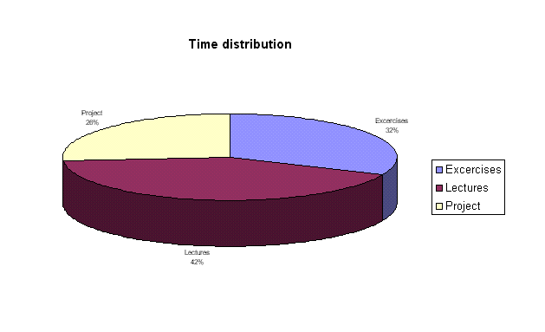Graphical reports:
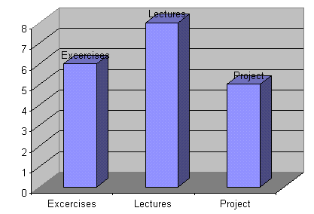

Appendix 3: Requirements Table
ID | Date | Source | Description | Rationale | Priority
1 | 26.10.02 | Customer | Easy insertion of data, and creation of standard reports | Usability | High
2 | 26.10.02 | Customer | Learning time should be minimal | Time saving, ease of use | High
3 | 26.10.02 | Customer | System management should be easy | Time saving | Middle
4 | 26.10.02 | Customer | Software must fit in a 1152 * 864 pixel screen so that the usage is possible without extensive scrolling all the time | Usability | Middle
5 | 26.10.02 | Customer | Project plan required | Maintainability | High
6 | 26.10.02 | Customer | Requirements document required | Maintainability | High
7 | 26.10.02 | Customer | Implementation Plan required | Maintainability | High
8 | 26.10.02 | Customer | Project Binder required | Maintainability | High
9 | 26.10.02 | Customer | Data manipulation | Core functionality | High
10 | 26.10.02 | Customer | Creation of reports and graphics | Core functionality | High
11 | 26.10.02 | Prject manager | Simple implementation | Time saving, maintainability | Middle
Appendix 4:

Scenario Description 1
Name | Create new database dialog
Actors | User
Preconditions | Created project
Description | The user enter the name of the project, initial date and the deadline
End Result | A database is created and the main screen is shown.

Scenario Description 2
Name | Adding a new field dialog
Actors | User
Preconditions | Created database
Description | The user click on “Add field” button and fills in the values in the “Add field” dialog.
End Result | Database updated with the new field.

Scenario Description 3
Name | Deleting a field
Actors | User
Preconditions | A field is selected
Description | The user clicks on the “Delete field” button.
End Result | The field is removed, database is updated.

Scenario Description 4
Name | Insert record dialog
Actors | User
Preconditions | The database has at least one field
Description | The user clicks on the “Add record” button and fills in the values in the dialog box.
End Result | The database is updated, record is added.

Scenario Description 5
Name | Change record dialog
Actors | User
Preconditions | A record exists and is selected
Description | The user clicks on the “Change record” button and fills in the values in the dialog box.
End Result | The database is updated, record is changed.

Scenario Description 6
Name | Delete record
Actors | User
Preconditions | A record exists and is selected
Description | The user clicks on the “Delete record” button.
End Result | The record is deleted.

Scenario Description 7
Name | Create report dialog
Actors | User
Preconditions | A record exists
Description | The user click on the “Create report” dialog and chooses the type of report.
End Result | The procedure for creting reports is called, possibly asking additional information (scenarios 8 and 9)..

Scenario Description 8
Name | Monthly report dialog
Actors | User
Preconditions | A type of report was selected (scenario 7)
Description | User selects month in the “Select month” dialog box.
End Result | A monthly report is created

Scenario Description 9
Name | Save final report dialog
Actors | User
Preconditions | User selected final report in scenario 7.
Description | User selectes file name and location in the “Save report” dialog box.
End Result | Final report is saved on disk.

