LTKK
Lappeenranta University of Technology
Department of Information Technology

Software Quality Assurance Report
Time Accounting Software

Author: Alexander Kanavin
Student number: 0242537
E-mail: kanavin@lut.fi
Supervisors:
Yana Selioukova
Email: Yana.Selioukova@lut.fi
Jan Voracek
E-mail: jan.voracek@lut.fi

Lappeenranta, Finland

2002

1. Introduction. 3
2. Purpose of this document 3
3. Scope and objectives 3
3.1. System functions 3
3.2. Testing criteria and constraints 4
3.3. Testing scope 4
4. FORMAL REVIEWING 4
5. Software Configuration Items in This Project 5
6. Change Control in This Project 6
7. RESOURCES 6
8. References 7

Introduction.
The purpose of the time accounting software is to assist in recording the working hours
used for different projects and reporting these hours to different people. The key functionality of the software is storing the time usage data, allowing easy insertion of data, and creation of standard reports [2].
The key functionality for the software is the data insertion, monthly report as an appendix to customer bills, and two graphic presentations of the time used for each project. The first one is a cumulative time during the project lifetime and the other one is a pie chart showing how the time is distributed between different activities. The time accounting software has currently only one interface to other systems, which is an ASCII file for copying the project data to company central project base [2].
The system consists of one page of MS Excel workbook with control elements.
Language of software interface and reports is English. All interface components as dialog windows are standardized to the universal format. The system data will be entered and produced in the Excel format. For changing system data you can apply standard Excel toolbox. The final report is generated and stored in ASCII text format. Graphical reports are presented as MS Graph 2000 components and can be stored to the picture format [3].

Purpose of this document
The SQA Report document provides principles of Time Accounting Software testing
strategy, reviewing of this project, configuration management and describes roles, resources and responsibilities of this project.

Scope and objectives

System functions
The user should be able to create projects, to add and delete fields into the project table, to create and remove entries (rows) of the table and to produce compose monthly, final and graphical reports based on existing data.

In order to provide these features, the Time Accounting Software should perform the following functions:
1. Create new project – a new project is created, the user specifies a project title, initial
data of project and the deadline.
2. Gather user information – the user enters his personal information.
3. Add new field – a new field (column) is added to the Time Accounting table.
4. Delete existing field – an existing field with data is removed from the Time Accounting table.
5. Add new entry – the user adds new information about some activity with the duration and date.
6. Change existing entry – the user changes duration of activity.
7. Delete existing entry – the user deletes information about some activity (change
duration to zero), if this entry stays empty, then it is removed from table.
8. Produce reports – Produce three type of reports: monthly, final and graphical reports.
The implemented interface should be ergonomic and friendly; all function should be easy to understand.

Testing criteria and constraints
The software requirements are the foundation from which quality is measured. The requirements for this project can be found in the Requirements document. The constraints of the project can also be found in the Requirements document.
We can base the quality measurement of the software on the requirements and constraints, given, respectively, in the Requiremenrs document[3] and the Project Plan[2].
We can formulate the following quality critera, based on that:
1) Easy and understandable human/machine interaction;
2) Timeliness of preparing reports and code
3) The look and functionality of the software.

Testing scope
Quality control is different for each quality criteria. Understandable human/machine interaction is verfied by scenario descriptions of software (see Appendix 4 of Requirements documentation). Timeliness of preparing reports and code is controlled by providing the reports and parts of software to customer at every deadline of the project. The look of software can be checked in the Requirement documentations of the project. The functionality of software can be checked by the use of test cases (see Appendix 4 of Requirements document for test scenarios).
System testing will not be used because our software is very simple and using full testing scenario is excessive for the project. The Unit test will be provided by use Test cases (see Appendix 4 of Requirements document for test scenarios).
Validation testing will include testing of the following criteria:
o All UI requirements (see Requirements document),
o and SF1-4 requirements (see also Requirements document).
At this step the project constraints will be checked also.

FORMAL REVIEWING
There will be several formal review points before and during system test, including the review of this document. This is a vital element in achieving a quality product [4].
1. Design Documentation - Requirements Specification & Design Specification
2. System Test Plan
3. Unit Test Plans & Test Conditions
4. Unit Test Results
5. System Test Conditions
6. System Test Progress/Results
7. Post System Test Review
8. Integration Test Results (Validation part)
9. Pilot Implementation Review
10. Project Review [4]

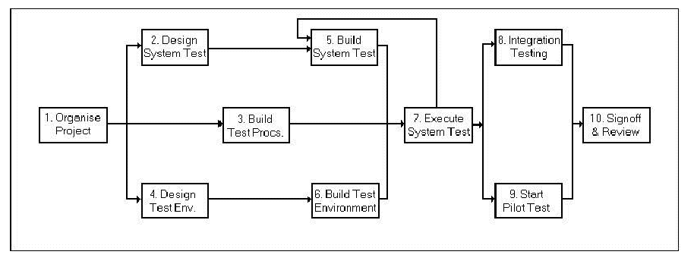
The diagram above outlines the Test Approach. Boxes 1 - 6 show the major review
stages prior to Test execution. Boxes 7 - 10 show the phases planned for & after test execution.
While the above diagram concentrates on the testing aspect of SQA's role, there is an
ongoing role also, in ensuring the quality of the major deliverables throughout the lifecycle ofthe project [4].

Software Configuration Items in This Project
This project has three types of SCIs:
- Project documents
- Test cases
- Program components
The project documents consist of Project Plan, Requirements Documentation, Implementation Plan, and Project Binder. Test scenarios are includued in Appendix 1 of Requirements document and are presented as one module. Program components are Excel Visual Basic for Application (VBA) functions. All functions of software can be presented as one SCI module, because they are relatively simple and the project has only one implementation step.

Change Control in This Project
Because the the time accounting software project is very small software we are not using the baseline concept or the version control system. The change control procedure, initiated by the customer is outlined below.
- Need for change is recognized
- Change request from customer arrives
- Developer evaluates
- Change report is generated
- Change control authority makes a decision, if the request is denied, customer is informed, and the procudure stops, otherwise it continues
- Request is queued for action
- Individuals are assigned to configuration objects
- The change is made
- The change is reviewed and audited
- The current version of software is rebuild
- Quality assurance and testing activities are performed
- The change to all configuration items is reviewed (audited)
- The new version is distributed

RESOURCES
Human
Alexander Kanavin
o Design of testing methods and test cases;
o Testing documentation;
o Validation and verification;
Hardware
IBM PC compatible system [2]
Software
MS Excel 2000 – as application platform for the project [2]
MS Windows 2000 – operating system for the project [2].

References
1. Pressman, R. S.: Software Engineering, A Practitioner's Approach (European adaptation,
fifth edition). McGraw Hill, 2000.
2. Project plan of Software Engineering project
3. Requirements documentation of Software Engineering project
4. Implementation plan of Software Engineering project
5. User’s guide of Software Engineering project
6. Elisabeth Boonin, Using Excel Visual Basic for Applications, QUE, 1996
7. Sample software system test plan for a new application 1)
http://members.tripod.com/~bazman/frame.html

